F07C UAV Detector
Accurate, All-Round, Long Range

Product Introduction
UAV detector is used to receive radio waves and analyze the signals from the controller to the drone and vice versa. Drones operate in different parts of the radio spectrum depending on the type of drone, communication link and video link. Once detected, RF devices can also identify the manufacturer and type of the drone.

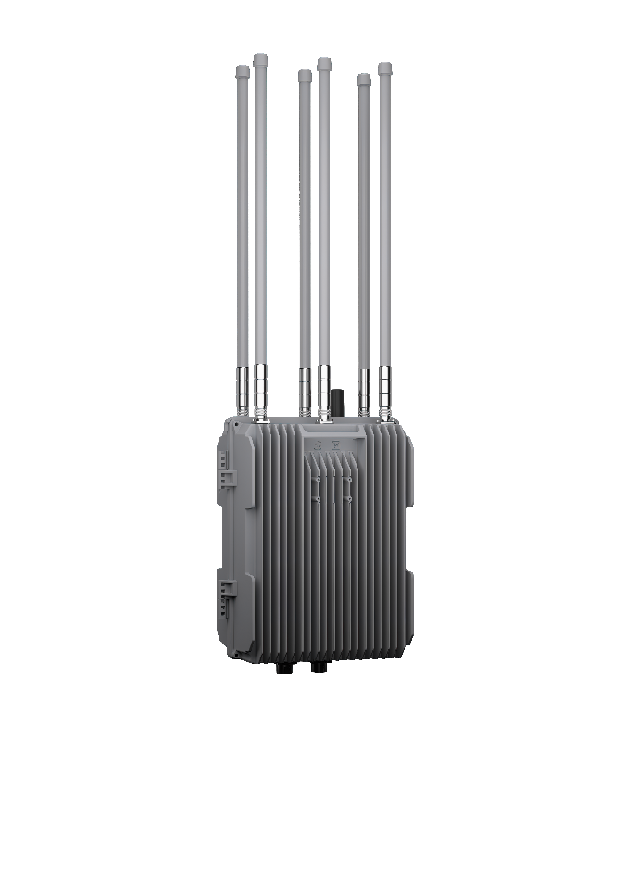

Product Features
- Detection capability: DJI, Autel and other types of drones
- Decoding capability: For DJI series and remote ID drone, it can locate the drone and remote control (pilot)
- RF spectrum analyzers: Detecting real-time frequency information, report the type and current operating frequency of drones
- Multi target tracking: Locating and tracking drone swarms
- Black and white lists
- Cooperating with jammer or spoofer automatically

Product Parameter
- DJI and remote ID decoding: SN, model, position (longitude, latitude and azimuth), speed, height, flight path and pilot position
- Frequency range: 400MHz, 900MHz, 1.4GHz, 2.4GHz, 5.2GHz, 5.8GHz
- Detection range: ≥5km（Related to environment and UAV model）
- Azimuth coverage: 360°
- Power supply: AC 220V
- Operating temperature: -25℃/55℃
- Storage temperature: -40℃/70℃
- IP Rate: IP 65
- Dimensions(W*D*H): 300*230*1320mm
- Weight: ≤15.0kg

