SR007 UAV Decoder
Flexibly, High Density, Cost-Effective

Product Introduction
The Remote ID (RID) technology is the core approach to achieving flight traceability and airspace safety management, as well as the core infrastructure of the low-altitude economy.
UAVs broadcast real-time information such as SN, longitude and latitude, altitude, speed, heading and the position of pilot directly, ensuring that regulatory authorities, law enforcement agencies and other airspace users can dynamically monitor the activities of drones.
UAV decoder is used for RID detection which is small size, light weight and cost-effective, can be deployed flexibly
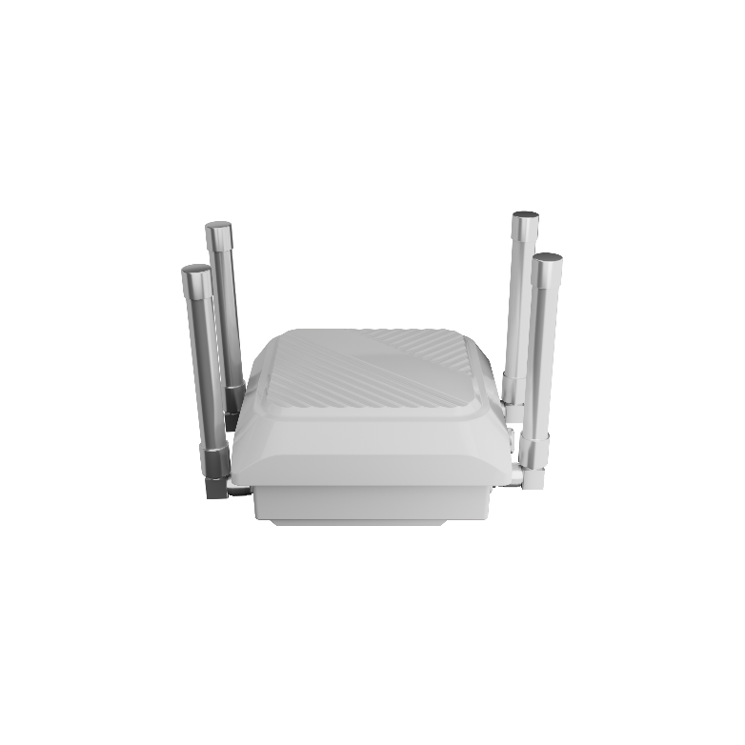
Product Features
- Technical Standard: ASD-STAN PrEN 4709-002, ASTM F3411-22a, GB 42590-2023
- Remote upgrade and configuration reduce operation costs
- Multi device networking access to meet high-density access scenarios
- Upload device status and drone detection data through Ethernet port or 4G network (optional)
- Supporting multi power supply modes: POE, DC, PV (optional) and AC 220V (optional)

Product Parameter
- Detection type: Remote ID
- Detection range: ≥3.0km(Related to environment and UAV model）
- Azimuth coverage: 360°
- Power supply: POE/DC/PV(Optional)/AC 220V(Optional)
- Operating temperature: -20℃/55℃
- Storage temperature: -20℃/60℃
- IP rate: IP65
- Dimensions(W*D*H): 250*250*300mm
- Weight: ≤2.0kg

